INFORMATION SYSTEMS AND DATABASES – PORTFOLIO ELEMENT 3



Student Name: Abhey Saini

1)ASSUMPTIONS/BUSINESS RULES:
- Each lecture is assigned to only one topic but a topic could have one or more lectures.
- A lecture will be arranged by only one staff member.
- There is only one assigned speaker for a particular lecture but the lecture may be for a cohort or more than one cohort.
- Only students can give feedback to the guest lectures. Only one feedback per student to a particular lecture moreover a student can give feedback to multiple lectures. However, submitting feedback is optional.
- It is optional for a lecture to get feedback, but if a lecture gets feedback there can be one or more feedback to a particular lecture by different student.
- Each lecture will have a unique timetable.
- Each speaker is connected to only one business, but a business can have one or more than one speaker. It is must for business to have at least one speaker.
- A speaker can have one or more expertise.
- It is not mandatory for speaker to have available slots for guest lectures but if a speaker is available then, he/ she can have more one or more than one slots for lectures
- It is optional for a business to provide placement, but the placement should belong to only one business. Moreover, a business can provide one or more than one placement.
- It is optional for placement to have feedback but only there will one feedback for each placement. A student can give feedback to multiple placements.
- A student may or may not go for placement, but if they do, they can have one or more placements.
- A student can belong to only one cohort and for cohort may or not have students.
- only one staff member is designated to a business. staff may or not connected to business.
- It is optional for staff to make lecture request, placement request and make contact to business if they do, they can request or contact multiple times.
- A request for lecture is dedicated to only single topic.
- It is optional for a topic to be requested for lecture. However, a topic can be requested one or more than one times
- There is a contact history table to track the communication between staff members and businesses. It is optional that a business is contacted if there is communication, a business can have one or more than one communication history.
- There should be announcement table to track all the indispensable announcements regarding placements, guest lectures, and so on

2) ER DIAGRAM:

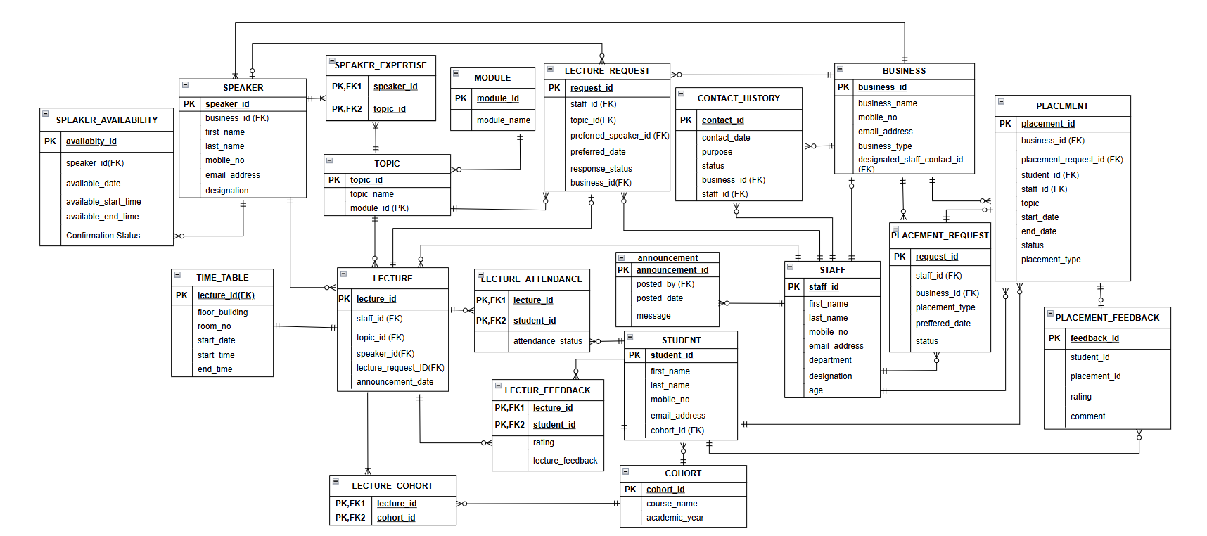

3) ENTITY SPECIFICATION FORMS

ENTITY NAME: STAFF
Entity description: stores details of all the staff members of the university

Attributes | Data types and width | Status* | Validation | Example of input and any relevant information
Staff_id | NUMBER (4) | pk |  | 101
First_name | VARCHAR2(30) | nn |  | anuradha
Last_name | VARCHAR2(25) | nn |  | sethi
mobile_no | VARCHAR2(15) | nn |  | +449876543567
email_address | VARCHAR2(254) | nn |  | anuradhaofficial@gmail.com
department | VARCHAR2(10) | nn |  | computing
designation | VARCHAR2 (20) | nn |  | professor
age | NUMBER(2) | nn | Age should be between 20 to 70 | 30

ENTITY NAME: LECTURE
Entity description: stores details of all the lectures arranged by staff members

Attributes | Data types and width | Status* | Validation | Example of input and any relevant information
lecture_id | NUMBER (5) | pk |  | 1001
staff_id | NUMBER (4) | fk |  | 101
topic_id | VARCHAR2 (8) | fk |  | T1000001
speaker_id | NUMBER (4) | fk |  | 2001
Lecture_request_id | VARCHAR2 (5) | fk |  | R1001
announcement_date | DATE |  |  | 23 Jan 2025

ENTITY NAME: SPEAKER
Entity description: stores details of all the external speakers

Attributes | Data types and width | Status* | Validation | Example of input and any relevant information
speaker_id | NUMBER (4) | pk |  | 2001
first_name | VARCHAR2(30) | nn |  | aman
last_name | VARCHAR2(25) | nn |  | khurana
email_address | VARCHAR2(254) | nn |  | khurana@gmail.com
mobile_no | VARCHAR2(15) | nn |  | +449087658907
designation | VARCHAR2 (15) | nn |  | ai expert
business_id | VARCHAR2 (5) | fk |  | BS101

ENTITY NAME: BUSINESS
Entity description: stores details of local business and staff members connected with it.

Attributes | Data types and width | Status* | Validation | Example of input and any relevant information
business_id | VARCHAR2 (5) | pk |  | BS101
business_name | VARCHAR2 (100) | nn |  | ai heath care
email_address | VARCHAR2 (254) | nn |  | officialai@gmail.com
mobile_no | VARCHAR2 (15) | nn |  | +449086112345
business_type | VARCHAR2 (30) | nn |  | health care tools
designated_staff_contact_id | NUMBER (4) | fk |  | 101
ENTITY NAME: SPEAKER_EXPERTISE
Entity description: stores details of speaker expertise

Attributes | Data types and width | Status* | Validation | Example of input and any relevant information
speaker_id | NUMBER (4) | pk, fk |  | 2001
topic_id | VARCHAR2 (8) | pk, fk |  | T1000001

ENTITY NAME: PLACEMENT
Entity description: stores details placements provided by different businesses

Attributes | Data types and width | Status* | Validation | Example of input and any relevant information
Placement_id | VARCHAR2 (5) | pk |  | 101
placement_request_id | VARCHAR2 (5) | fk |  | PR101
business_id | VARCHAR2 (5) | fk |  | BS101
Student_id | NUMBER (6) | fk |  | 100001
Staff_id | NUMBER (4) | fk |  | 101
topic | VARCHAR2 (50) | nn |  | data communication
Placement_type | VARCHAR2 (25) | nn |  | internship
start_date | DATE | nn |  | 1 Jan 2025
end_date | DATE | nn |  | 4 April 2025
status | VARCHAR2(10) |  | It should be either pending, placed or not placed | placed

ENTITY NAME: PLACEMENT_REQUEST
Entity description: stores details of all the requests sent for placement to businesses

Attributes | Data types and width | Status* | Validation | Example of input and any relevant information
request_id | VARCHAR2 (5) | pk |  | PR101
staff_id | NUMBER (4) | fk |  | 101
business_id | VARCHAR2 (5) | fk |  | BS101
placement_type | VARCHAR2 (15) | nn |  | internship
preferred_date | DATE | nn |  | 23 April 2025
status | VARCHAR2 (15) | nn | Either it is pending, approved or disapproved | approved

ENTITY NAME: PLACEMENT_FEEDBACK
Entity description: stores details of the feedbacks given by the students to the different placements

Attributes | Data types and width | Status* | Validation | Example of input and any relevant information
feedback_id | VARCHAR2 (6) | pk |  | PD1001
student_id | NUMBER (6) | fk |  | 100001
placement_id | VARCHAR2 (5) | fk |  | 101
rating | VARCHAR2 (5) | nn | It could be 1,2,3,4 or 5 | 5
comment | VARCHAR2 (250) | nn |  | Fantastic experience

ENTITY NAME: STUDENT
Entity description: stores details of students

Attributes | Data types and width | Status* | Validation | Example of input and any relevant information
student_id | NUMBER (6) | pk |  | 100001
first_name | VARCHAR2(30) | nn |  | rishab
last_name | VARCHAR2(25) | nn |  | khanna
email_address | VARCHAR2(254) | nn |  | khanna@gmail.com
mobile_no | VARCHAR2(15) | nn |  | +440987654321
Cohort_id | VARCHAR2 (6) | fk |  | CO1001

ENTITY NAME: COHORT
Entity description: stores details of cohort

Attributes | Data types and width | Status* | Validation | Example of input and any relevant information
cohort_id | VARCHAR2 (6) | pk |  | CO1001
course_name | VARCHAR2 (50) | nn |  | computer science
adacemic_year | DATE | nn |  | 2025

ENTITY NAME: LECTURE_COHORT
Entity description: stores details of which cohorts attended the guest lectures

Attributes | Data types and width | Status* | Validation | Example of input and any relevant information
Lecture_id | NUMBER (5) | pk |  | 1001
Cohort_id | VARCHAR2 (6) | pk |  | CO1001

ENTITY NAME: TOPIC
Entity description: stores details of topics

Attributes | Data types and width | Status* | Validation | Example of input and any relevant information
topic_id | VARCHAR2 (8) | pk |  | T1000001
module_id | VARCHAR2(5) | nn |  | ML101
topic_name | VARCHAR2 (50) | nn |  | algorithms

ENTITY NAME: MODULE
Entity description: Store details of all the modules offered by the university

Attributes | Data types and width | Status* | Validation | Example of input and any relevant information
module_id | VARCHAR2(5) | nn |  | ML101
Module_name | VARCHAR2 (250) | nn |  | Information systems and databases

ENTITY NAME: CONTACT_HISTORY
Entity description: stores details of all the contact history made by staff members to businesses

Attributes | Data types and width | Status* | Validation | Example of input and any relevant information
contact_id | VARCHAR2 (7) | pk |  | CON1001
Contact_date | DATE | nn |  | 25 Feb 2025
purpose | VARCHAR2(25) | nn |  | guest lecture
status | VARCHAR2(8) | nn | It is either accepted or, pending declined | accepted
business_id | VARCHAR2 (5) | fk |  | BS101
staff_id | NUMBER (4) | fk |  | 101

ENTITY NAME: LECTURE_REQUEST
Entity description: stores details of all the requests made by the staff for guest lectures

Attributes | Data types and width | Status* | Validation | Example of input and any relevant information
request_id | VARCHAR2 (5) | pk |  | R1001
staff_id | NUMBER (4) | fk |  | 101
topic_id | VARCHAR2 (8) | fk |  | T1000001
Preferred_date | DATE | nn |  | 1 Jan 2025
preferred_speaker_id | NUMBER (4) | pk |  | 2001
response_status | VARCHAR2(8) | nn | It is either accepted or, pending declined | accepted
business_id | VARCHAR2 (5) | fk |  | BS101

ENTITY NAME: TIME_TABLE
Entity description: stores details of when lecture will be conducted, where and so on

Attributes | Data types and width | Status* | Validation | Example of input and any relevant information
lecture_id | NUMBER (5) | fk |  | 1001
floor_building | VARCHAR (20) | nn |  | 3 pigeon
room_no | NUMBER (4) | nn |  | 101
start_date | DATE | nn |  | 23 Jan 2025
start_time | DATE | nn |  | 9.30 am
end_time | DATE | nn |  | 11.30 am
ENTITY NAME: LECTURE_ATTENDANCE
Entity description: stores details of which students attended the lectures

Attributes | Data types and width | Status* | Validation | Example of input and any relevant information
lecture_id | NUMBER (5) | fk |  | 1001
student_id | NUMBER (6) | fk |  | 100001
Attendance_status | VARCHAR2 (7) | nn | It should be either present, absent or late | present
ENTITY NAME: LECTURE_FEEDBACK
Entity description: stores details of all the feedback given by students

Attributes | Data types and width | Status | Validation* | Example of input and any relevant information
Lecture_id | NUMBER (5) | Pk, fk |  | 1001
Student_id | NUMBER (6) | Pk, fk |  | 100001
rating | NUMBER (5) | nn | It should be between 1 and 5 | 5
Lecture_feedback | VARCHAR2 (250) |  |  | excellent

ENTITY NAME: SPEAKER AVAIBILITY
Entity description: stores details of the speaker avaibility

Attributes | Data types and width | Status* | Validation | Example of input and any relevant information
Available_id | VARCHAR2 (7) | pk |  | AVL1001
Speaker_id | NUMBER (4) | fk |  | 2001
Available_date | DATE | nn |  | 10 May 2025
Available_start_time | DATE | nn |  | 09:00:00
Available_end_time | DATE | nn |  | 01.00.00
Confirmation_Status | VARCHAR2(3) | nn | It could be either no or yes | yes

ENTITY NAME: ANNOUNCEMENT
Entity description: stores details of announcements made by staff members.

Attributes | Data types and width | Status* | Validation | Example of input and any relevant information
Announcement_id | NUMBER (5) | fk |  | 1001
posted_by | NUMBER (4) | fk |  | 101
Posted_date | DATE | nn |  | 12 Jan 2025
message | VARCHAR2(300)

SQL TABLE CREATION SCRIPTS
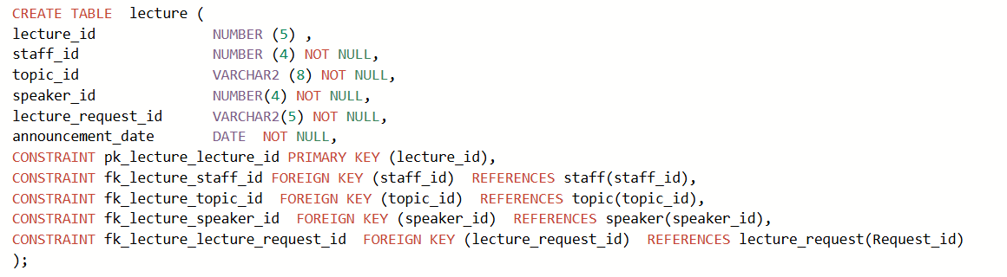
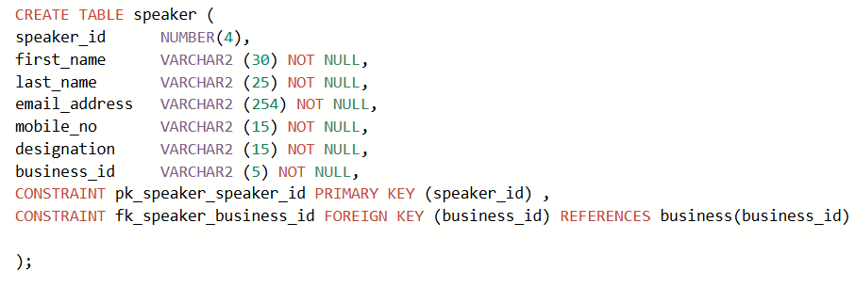

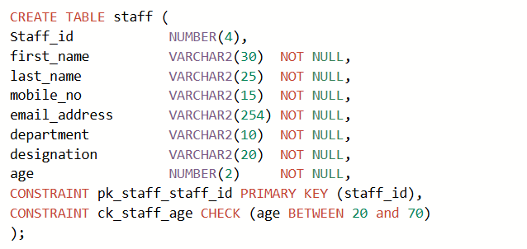
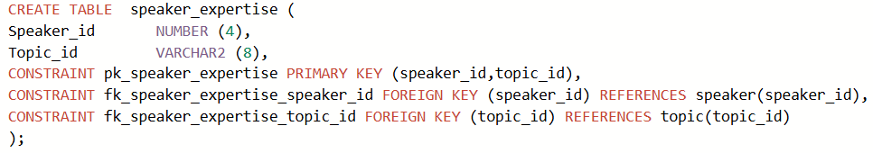

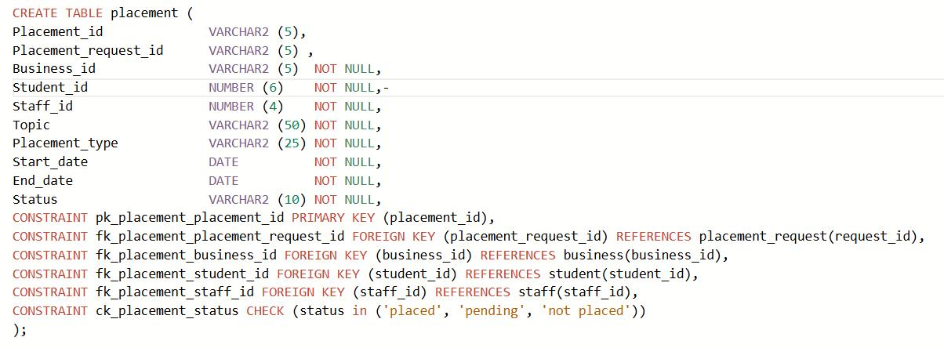

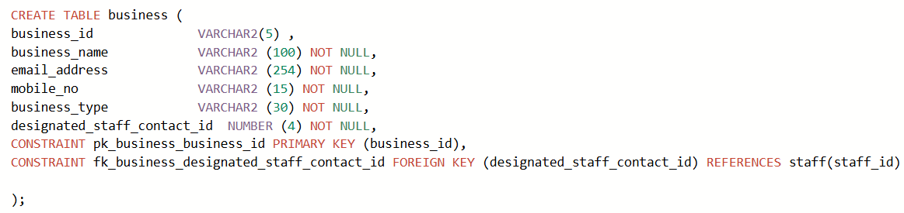
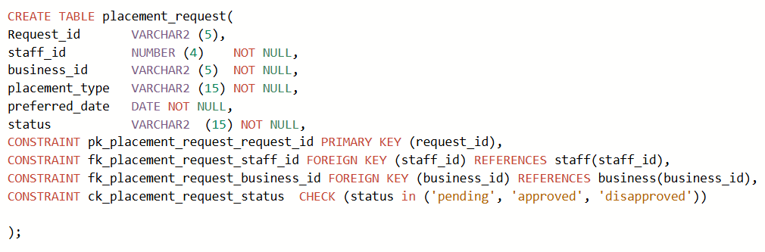

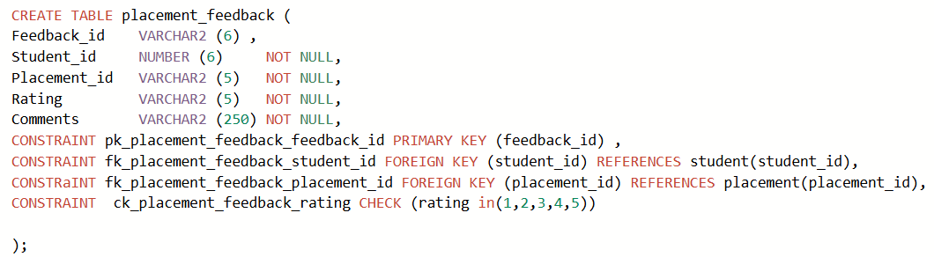
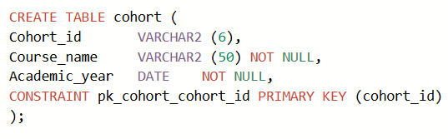
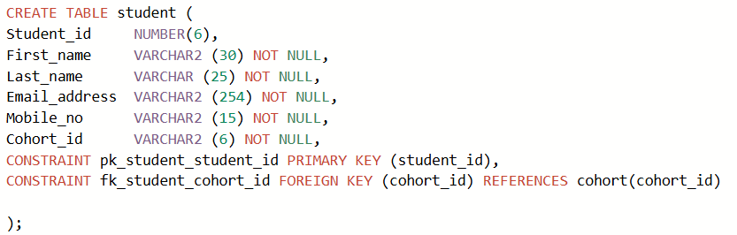
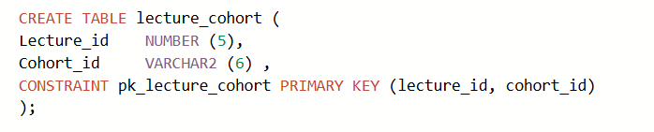

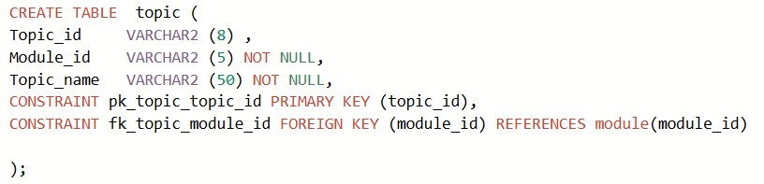

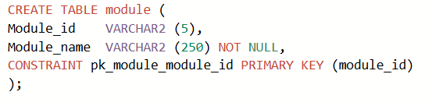

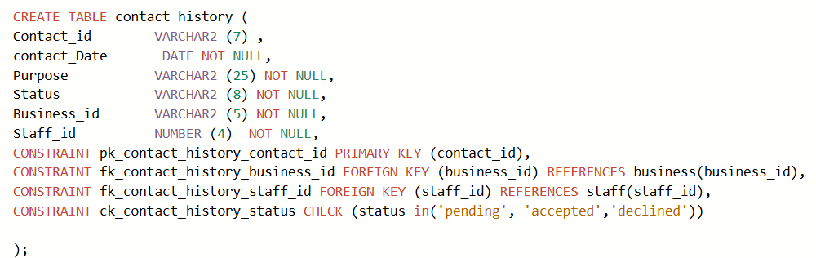
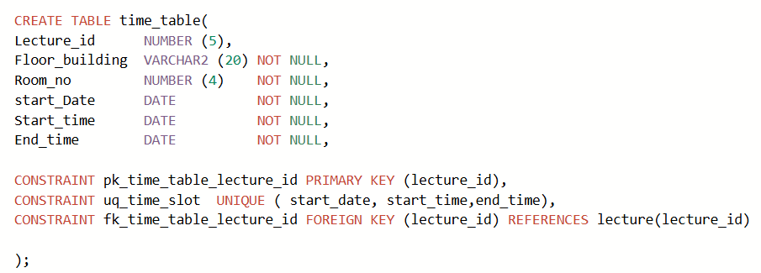
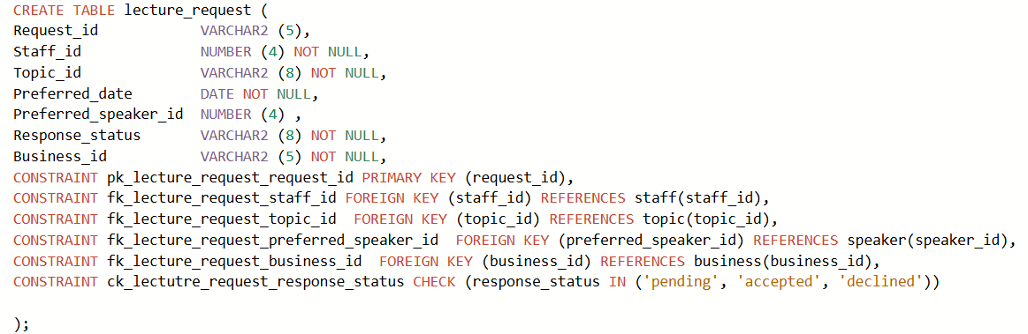

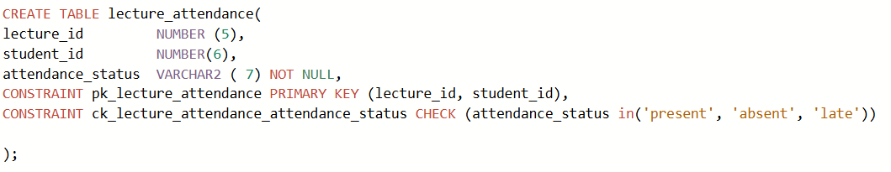
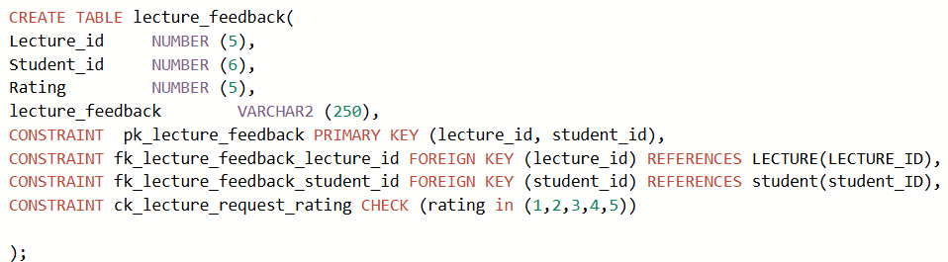

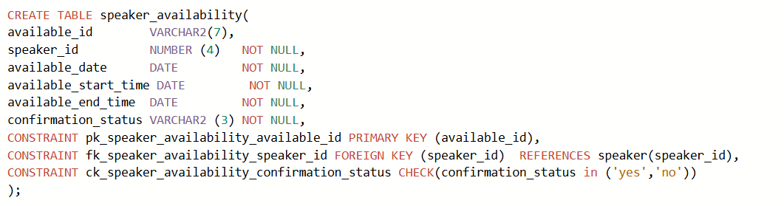

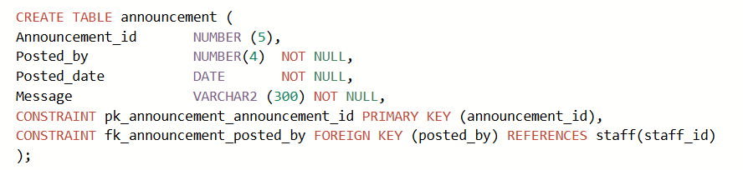
SAMPLE DATA
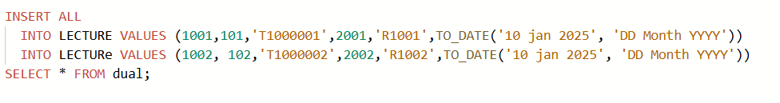
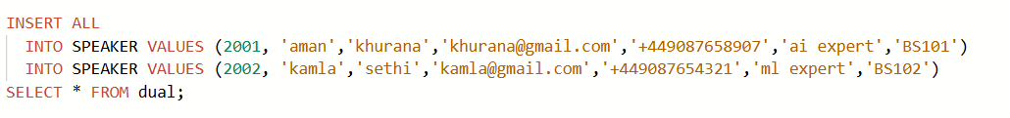
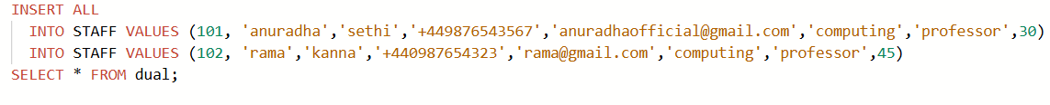
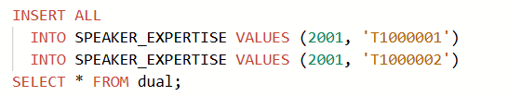
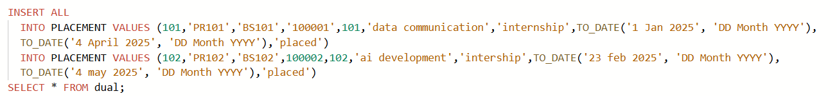

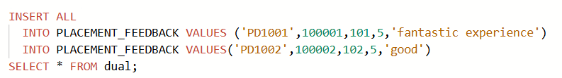

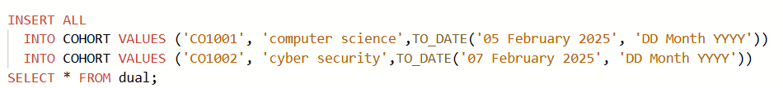
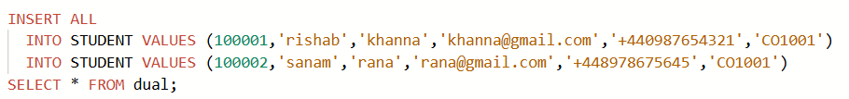
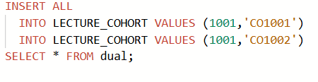
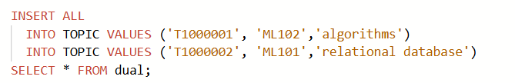

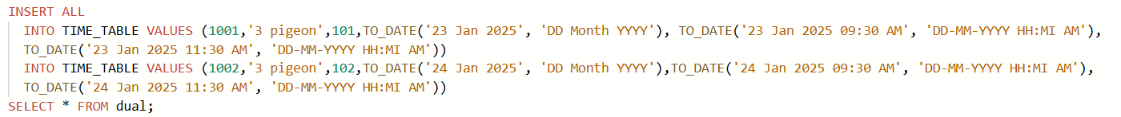



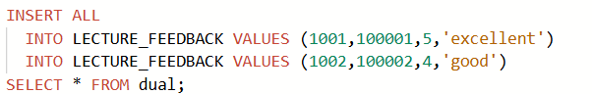
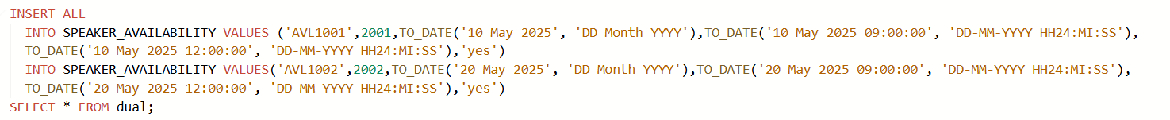

QUERIES
- This query can track the lecture information such as lecture id, what was the topic of the lecture, who delivered the lecture and the average rating of the lecture by the students.

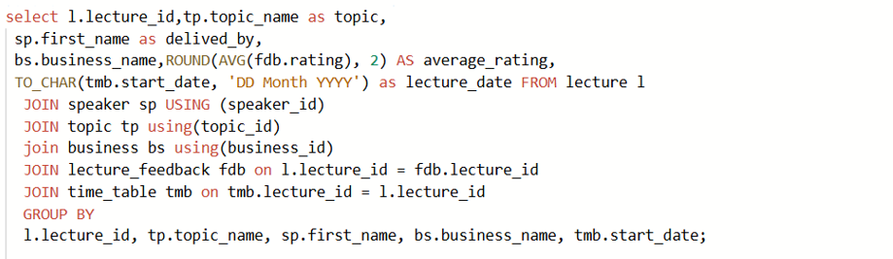

- This query will provide all the information about placements.
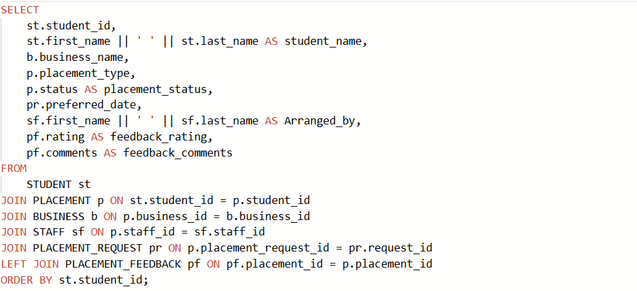
RESULT
- This Query will provide important information about speakers like name, their topic expertise, which topic belongs to which module
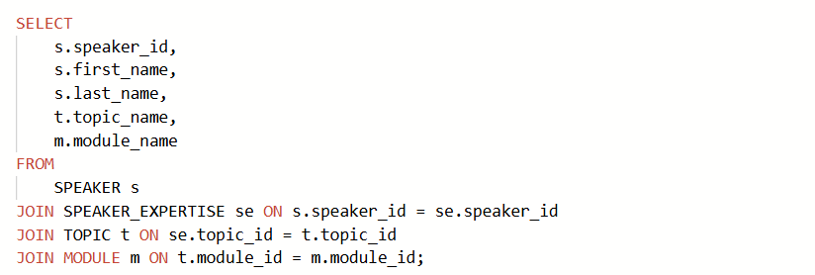

- This will provide the timetable information about a particular lecture, such as date, time, building, room no and about speaker as well.
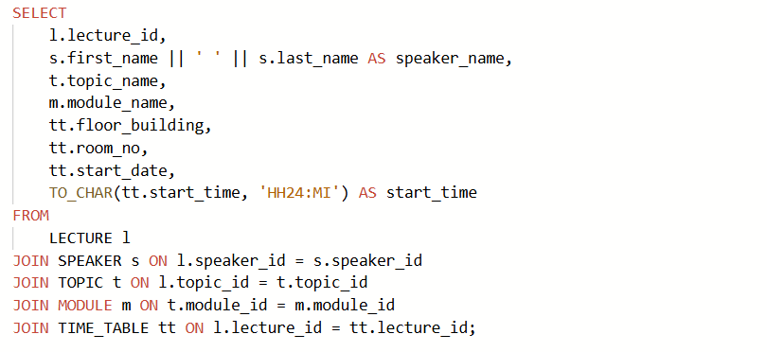

- It will provide the lecture information which has the rating less than three.
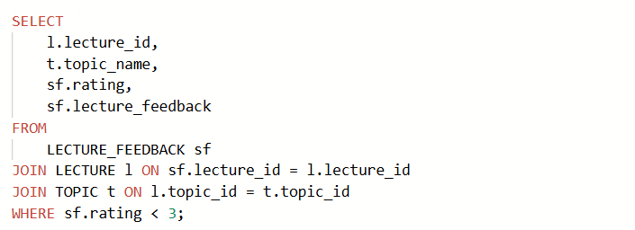
- This query will provide information about the speaker who did not deliver a single lecture.

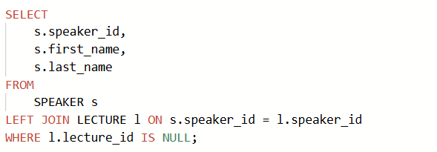

- This query will help to know how many students were placed by different businesses.

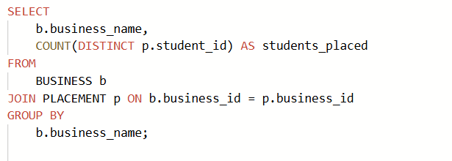
- It can help to track the information about the staff who are not active such as don’t provide announcements.
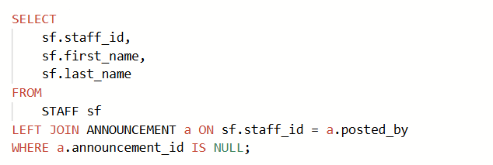

- Track the staff information which are not connected with businesses.

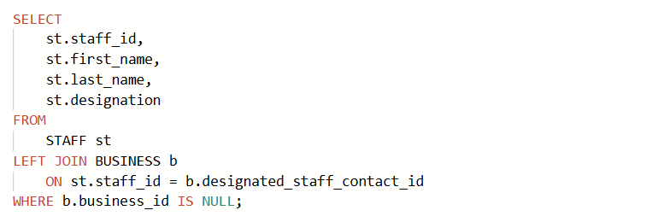

DATABASE SECURITY

Introduction:
now a days SQL is being used in multifarious of organization to store and retrieve data from the database. Database security is really very indispensable from unauthorised access. Oracle apex provides multiple layers of protection to secure the data from unauthorised users.
There are different ways to protect data such as:
- Authorisation
Authorization is very indispensable principle to secure data in database. It is all about who can excess the information in database and also what kind of specific operations done by the user is called authorization. It could be very essential in terms of data security as only authorised users can make changes or retrieve information from the database.
in a cooperate HR system, employees can see only their personal details like their appointments, working hours, salary and so on. But HR staff can update salary information, staff details, and so only but the manager can see only performance of their staff but cannot change payment data like salary. So, this shows how crucial is authorization. Specific users only can perform specific tasks only which are necessary for then. Hence because of authorization there is security for sensitive data.
- Authentication
Authentication is also important in terms of security as it verifies the users by password (unique identifier), and username. it can make sure only verified users can login and perform the tasks with the database and it prevents unauthorised access. Let’s take a real time example university database.
Let’s assume there is a university, the professors modify the students’ grades. There is a username and a password for professors to accomplish the task. If an unauthorised user will try to login with wrong password and user name, the access will be defined.
In a bank when user has to
- Access
The third security measure could be granting and revoking of privileges. A privilege is the permission to retrieve or modify data from the database. Giving privilege is very important who should have appropriate privilege otherwise database can be compromised if it is not given properly. privileges should be given to those who cannot manage without them or cannot execute their work. The following is the real example that shows how important it is.
Let’s assume there is a hospital. Doctors have access to the patients’ health status and medical history and a receptionist has access of patient appointments details only. If privileges are not set properly, the receptionist could access the sensitive data which is not secured and big blunder.
- Encryption
‘If a database system sensitive data, it may be hacked by unauthorised users the chances are high. Some DBMSs provide an encryption facility for this purpose in order to protect data. The DBMS can access the data (after decoding it). Encryption also protects data transmitted over communication lines. There are ample of methods for encoding data to conceal the information’.
- Integrity
Integrity is must to maintain security in RDBMS, it ensures that the data is trustworthy, consistent. We should add proper constraints like primary key, foreign keys, CHECK constraint on oracle database to make sure the data in database is accurate and arranged in proper manner. Without integrity, data could be corrupted.
For real example let’s assume there are two tables, customers and orders. A customer can order many orders but one order belongs to only one person. There is one to many relationships. If customer id is not put properly in order table as a foreign key then it could cause problems table will not be connected and there will not be results if user tries to retrieve data using joins.

ANOTHER DATABASE

NO SQL databases store data without a structured mechanism to link data from different tables to one another. The indispensable advantage is that it needs low – cost hardware as compared to relational databases. It is faster than relational databases in operations such as (read/write) and best for online analytical processing. It has no fixed columns as relational database hence it is free from schema. ACID transaction properties are not required. Some examples of no SQL databases such as MongoDB, Redis, Cassandre and so on. There are different types of databases like column, key-value, graph, and document.
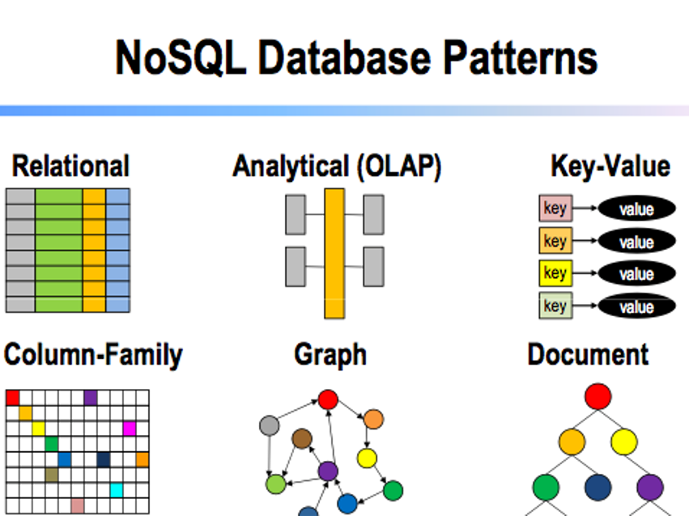
COLUMNAR DATABASE
It is quite different from relational database because it uses columns to store data instead of rows to store data. It is memory efficient; it takes less space in memory as compared to relational database. It is used to store and manipulate data large data effectively. Arithmetic operations like min, max average is quite easy to calculate as compared to RDBMS. ‘Columnar databases store all the cells relating to a column as a continuous disk entry faster search/accesses’. Example of columnar database is Cassandra.
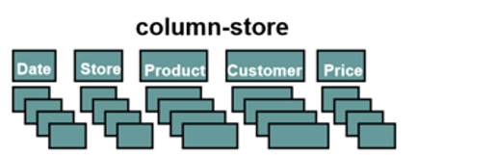
Example:
It is used in e commerce platforms to a great extent for analytical process, such as to find out what is total revenue, what is top selling product, average sales and so on. It is used specifically because it is very easy to do arithmetic operation by using the columnar database such as average, addition, multiplication and many more.

DOCUMENT DATABASE
Document databases store semi-structured data like JSON or XML that make it easy for developers to work with the same format used in their code. They offer flexible schemas which is best for dynamic data that may change over time. This type of data base is best for storing catalogs. Apps like Netflix, amazon, amazon prime use this database. This database is best for apps or websites where there is constant change in data of users in a very large amount and where there is need to make catalog for example recommendation systems on Netflix and products listing on shopping websites.
Example:
On amazon when a user searches a query like shampoo, all the products are shown which are categorized as shampoo. In a document database, each product is stored as a self-contained document (usually in JSON format), containing fields like name, category, brand, price, tags this helps to query based on specific such as ‘shampoo’.
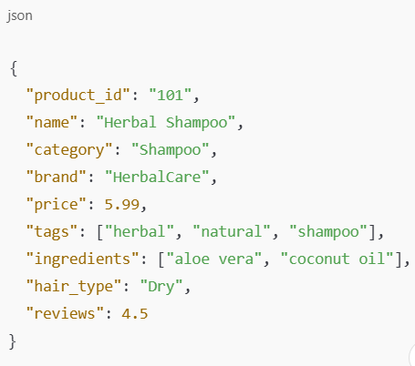

KEY – VALUE DATABASE
A key – value DB is a simple DB that uses an associative as a fundamental model. Where each key is connected with one and only one value in a collection. It is very simple database. Operations on it for query are fast on it and it allows horizontal scaling. One of the most powerful uses of this database is caching, it stores frequently accessed data temporarily in RAM instead of going to the main database again and again every time. It not only saves the resources of the organization as well improve the speed of the app or website.
Example : Amazon ElastiCache for Product Page Loading:
If multiple users are going to same product, Amazon uses ElastiCache (a key-value store) to store the data temporarily in order to give fast results, save resources, and reducing burden on the database.
GRAPH DATABASE
A graph DB is basically a collection a collection of nodes and edges. ‘Each node represents an entity and each edge represent a connection between two nodes’ . It is very useful for large data’, in this database’ there is no need to do computation on query time data is just there after being computed, node relationships are already pre-computed’ just user has to traverse only for collecting information. More deep data can be retrieved from the database as compared to RDBMS. Let’s assume a scenario:
In social networking apps like Facebook a user has different activities like doing comments, like pictures, following and so on. It has billions of users so different users execute these activities hence to track on these activities like who is whose friend, who follow who, who’s like who’ picture the Graph Database is beneficial for such kind of social apps. Inclusion, for networking apps or website this database is beneficial and efficient.
Example - Neo4j Aura DB
Applications: representing social networks, pattern detection etc
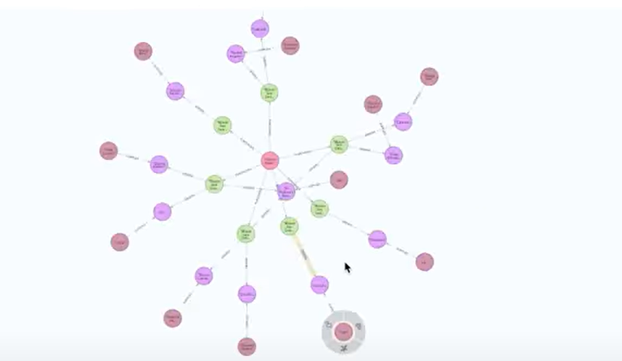
REFRENCES:

https://www.mongodb.com/resources/basics/databases/document-databases
https://www.youtube.com/watch?v=H-A7VdONggM
lecture notes
https://www.youtube.com/watch?v=NvjKXwt7n48
Database systems: a practical approach to design, implementation and management by Connolly Thomas

